Ideation Phase
Brainstorm & Idea Prioritization

Date | 2 january 2026
Team ID
Project Name | SuperBuy – E-Commerce Platform
Maximum Marks | 4 Marks

Brainstorm & Idea Prioritization
Brainstorming provides a free and open environment that encourages all team members to actively participate in the creative thinking process. It promotes collaboration, idea-sharing, and innovative problem-solving. During this phase, emphasis is placed on generating a wide range of ideas without immediate judgment, allowing creativity to flow freely.
This brainstorming activity helped the team conceptualize SuperBuy, an e-commerce platform designed to simplify product discovery, purchasing, and management for users, sellers, and administrators.
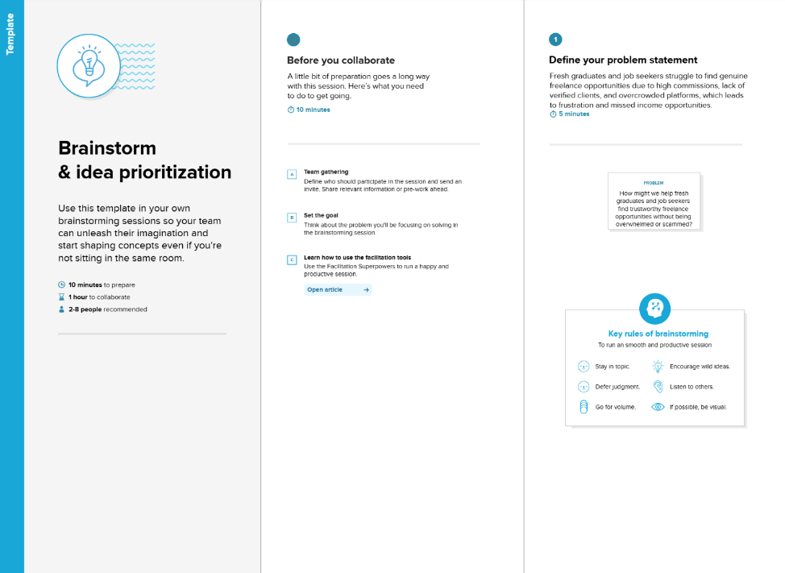

Step 1: Team Gathering, Collaboration, and Problem Statement Selection
The team conducted collaborative discussions to identify real-world challenges faced by users, sellers, and administrators on existing e-commerce platforms. The key challenges identified include:
- Difficulty in managing products and orders efficiently
- Limited platforms supporting multiple user roles (Customer, Seller, Admin)
- Lack of centralized dashboards for monitoring activities
- Poor user experience during product discovery and checkout
Problem Statement:
To design and develop a user-friendly, secure, and scalable e-commerce platform that enables users to browse and purchase products easily, allows sellers to manage inventory efficiently, and provides administrators with complete control over platform operations.

Step 2: Brainstorming, Idea Listing, and Grouping
During brainstorming sessions, the team generated multiple ideas and grouped them based on functionality and relevance.
Ideas Generated:
- User authentication and role-based access
- Product browsing with category-based filtering
- Search functionality for products
- Wishlist management
- Cart and checkout system
- Dummy payment integration
- Order history tracking
- Product review and rating system
- Seller dashboard for product management
- Admin panel for managing users and sellers
- Image upload for product display

Idea Grouping
User Features
- Browse products
- Add products to cart and wishlist
- Place orders
- View order history
- Manage profile
Seller Features
- Add, update, and delete products
- View listed products
- Track and manage orders
Admin Features
- Manage users and sellers
- Monitor platform activity
- Oversee product listings and orders

Step 3: Idea Prioritization
After evaluating feasibility, impact, and importance, the ideas were prioritized as follows:
High Priority
- User authentication and authorization
- Product listing and browsing
- Cart and checkout system
- Role-based dashboards
- Order management
Medium Priority
- Wishlist functionality
- Product reviews and ratings
- Seller performance analytics
Low Priority / Future Enhancements
- Advanced recommendation system
- Online payment gateway integration
- Real-time notifications

Final Outcome
The prioritized ideas were used to design and develop SuperBuy, ensuring a balanced focus on usability, scalability, and performance. This structured ideation process enabled the transformation of concepts into a functional and efficient e-commerce platform built using the MERN stack.

